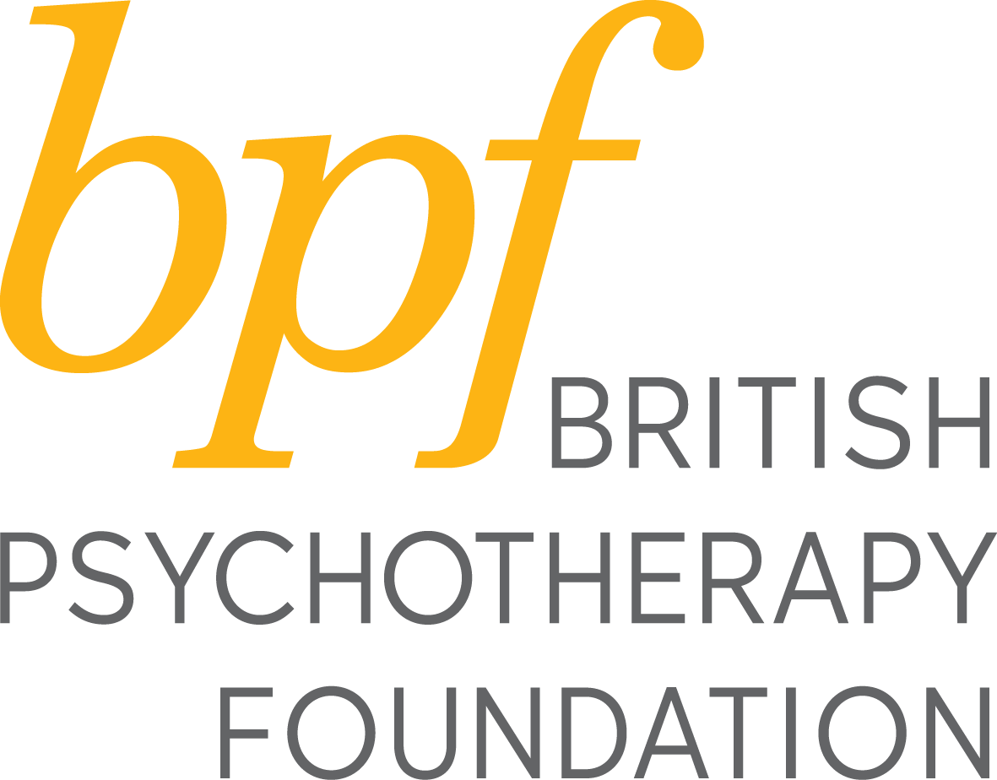

**Training with the NPPT at the *bpf***

**Background**

The practice of psychoanalytic psychotherapy seeks to explore, understand and work in depth with the emotional problems of another. The **Northern Psychoanalytic Psychotherapy Training** offers a clinical pathway to becoming a psychoanalytic or psychodynamic psychotherapist, working with adults, which is accredited by the British Psychoanalytic Council. This part-time training includes a combination of in-person and online teaching. The structure is designed to fit around current work commitments.

**Training**

There are two routes to qualification: Full Training (Psychodynamic or Psychoanalytic) and the Modified Entry, for those who are already trained as Child and Adolescent Psychotherapists with the Association of Child Psychotherapy, or Adult Psychoanalytic/Psychodynamic Psychotherapists who are not currently registered with the BPC.

* The **Full Training** is suitable for people who do not have a prior psychotherapy training and/or have not undertaken a previous intensive personal therapy.
* The **Modified Entry** route is for those who already have a qualification in psychodynamic/ psychoanalytic therapy as an adult therapist, child psychotherapist or couple therapist and who have undertaken an intensive personal therapy with an approved therapist.

**Preparing to apply**

Prospective applicants for either route should read the necessary prior requirements for training which are set out in detail on the website. If you have contacted the Training Manager,

and would like to consider arranging to speak to a NPPT advisor, you will have received this questionnaire which we hope you will fill in, answering as many questions as possible.

An advisor can help enquirers who have given the prospect of training serious consideration to think how to prepare to apply for either the Full Training or the Modified Entry route, as well as answer any questions about the structure, content and costs of the training.

**Confidential Questionnaire**

The questionnaire is designed to help all those interested in undertaking an intensive training in psychodynamic or psychoanalytic psychotherapy with the NPPT to consider their readiness to apply, and to reflect on the questions it would be helpful to discuss with an advisor.

It is also designed to give NPPT advisors some information in order to be prepared for a call.

Once you have completed the questionnaire, please contact the training manager at [nppt@bpf-psychotherapy.org.uk](mailto:nppt@bpf-psychotherapy.org.uk) to arrange to speak to an advisor

* **if** you are at the point of applying to train with the NPPT;
* **or** if you have started working towards applying and you feel that it would be beneficial to have a discussion with an advisor.

**CONFIDENTIAL**

Questionnaire

|  |
| --- |
| **UK General Data Protection Regulation (GDPR) Statement, May 2018:**  Under UK GDPR the ***bpf***is required to inform you that we will be asking you a number of questions so that we can help with your enquiry. This information is intended for the ***bpf*’**s use only and will be securely handled and processed.  The information you provide in this questionnaire will be used for the sole purpose of referring you to a ***bpf***advisor, who will be a member of the NPPT, and for supporting you in the process of enquiry and/or application. Any information you provide outside of this questionnaire, such as in person, over the phone, or in email, will also be used solely for the purpose of advancing your enquiry and/or application.  The ***bpf***produces statistical reports to measure the number of enquires, questionnaires and applications are received over specific periods of time. The information in these reports is anonymised and contains strictly non-identifying information.  The***bpf***relies on 'legitimate interest' as its lawful basis in order to collect information. Such information is read with 'substantial public interest' for any other sensitive piece of information that we may receive from you and that has special categories of data.  If you apply, and if your application is successful, we will continue to process your information on the lawful basis of contractual obligation for the duration of your training and up to 7 years post qualification. If you do not apply, or are unsuccessful in your application, we will store your information for a period of 2 years, after which it will be deleted.  If you have any concerns, please email NPPT@bpf-psychotherapy.org.uk |

**Please carefully read the NPP Training section of the *bpf* website which you can find** [**here**](https://www.britishpsychotherapyfoundation.org.uk/education/courses/northern-psychoanalytic-psychotherapy-training/) **and the accompanying notes on page 1 before completing this questionnaire as fully as possible.**

**FILL IN ELECTRONICALLY**

|  |  |
| --- | --- |
| 1. Name |  |
| 2. DOB |  |
| 3. Phone contact |  |
| 4. Email address |  |
| 5. Address |  |
| 6. How did you hear of the ***bpf*** and the NPP Trainings? |  |
| 7. Have you been in touch with the NPPT before? If yes, please tell us when and with whom you spoke. |  |
| 8. At the moment are you interested in the Full training or the ME route?  Or you may be uncertain and would like advice?    ***NPPT Training prerequisites for the two different routes (Full Training and M.E. routes) are on the website.*** | **Psychodynamic Psychotherapy**  Full [ ]  **Psychoanalytic Psychotherapy**  Full [ ] Modified Entry [ ]  [ ] Uncertain |
| 9. Would you describe yourself as being in the early stages of thinking about which training might be right for you? |  |
| 10. Or, would you describe yourself as being at the point of applying to the NPPT now? |  |
| 11. Please outline any previous courses attended (including start/end dates) related to counselling/psychotherapy / psychoanalysis including reading groups, introductory courses, academic studies and therapy training courses. |  |
| 12. Have you done an infant observation course? If so, please give details and dates. |  |
| 13. Have you had any experience of voluntary or paid work involving face-to-face work in a helping capacity– if so please describe. |  |
| 14. Have you had any experience of working in a professional capacity in a health or caring setting– if so please describe. |  |
| 15. Could you tell us if you have had experience of personal psychotherapy/analysis? If so, please give details with dates. |  |
| 16. Could you tell us briefly about your educational background, relevant qualifications,  employment history? |  |
| 17. Please feel free to add any additional information that would be helpful for the NPPT advisor to know, and which may be relevant to your enquiry. |  |

Thank you for taking the time to fill in the questionnaire.

**Signature:**

**Date:**