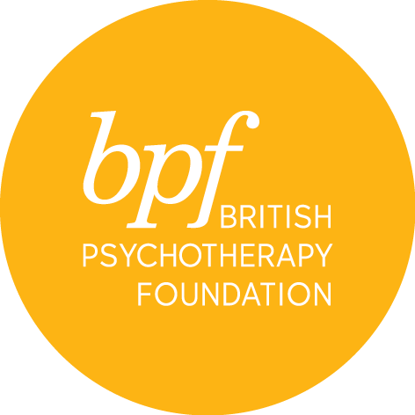

Jungian Dream Workshops

The workshops are open to therapists from all modalities, backgrounds, and

identities. We are committed to providing a space that is inclusive, queer friendly, neurodivergence aware and conscious of racial and cultural dynamics. The workshops are held online.

**Full Name**:

**Address**:

**Town**:

**Postcode**:

**Telephone**:

**Email**:

**Occupation**:

**Professional qualification**:

Place of Study:

Number of years in clinical practice as a qualified therapist:

If a trainee, how many hours of clinical work have you completed:

**Please give details of the discipline/orientation of your practice and/or any other relevant experience you may have.**

|  |
| --- |
|  |

**Are you, or have you been in individual or group psychotherapy?**

If so, please give details of length, frequency and discipline/orientation

|  |
| --- |
|  |

**What do you hope for from the course?**

|  |
| --- |
|  |

**Where did you hear about the course?**

|  |
| --- |
|  |

**Would you like to receive information about events and course at the *bpf*?** YES/NO

Payment via debit card only will be due on acceptance of a place.

I certify that the information contained in this application is true and complete. On signing this application form, I confirm that I have read and understood the cancellation and refund policies below.

**Signature**:

**Date**:

Please return the completed form electronically to Angelina Verduzco, BJAA Training Manager, – bjaatraining@bpf-psychotherapy.org.uk

**Cancellation**

All cancellations must be made in writing and subject to an admin fee of £25

100% refund will be given for cancellations up to 60 days before the course start date.

50% refund will be given for cancellations up to 30 days before the course start date.

No refund for cancellations received in less than 30 days before the course start date.