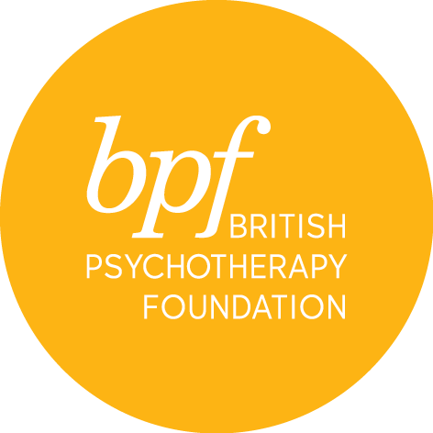

developing a psychoanalytic
approach to working with
children & adolescents

Please note that this course sets out to help individuals understand what is required in preparation for the child and adolescent psychoanalytic psychotherapy doctoral training but does not guarantee a place on the training.

Full Name:

Address:

Town:

Postcode:

Telephone:

Email:

Occupation:

Please let us know what you aim to achieve by attending this course?

Where did you hear about the course?

Would you like to receive information about events and course at the bpf? YES/NO

I certify that the information contained in this application is true and complete. On signing this application form, I confirm that I have read and understood the cancellation and refund policies.

Signature:

Date:

Please return the completed form electronically to Sandra Pereira, MSc, Post Graduate & Public Courses Officer at SandraP@bpf-psychotherapy.org.uk

